

**By**

**Sunil Raj Thota**

**Date: 06/21/2021**

**Title: XN Project: Individual Contribution**

**ALY 6080 – Integrated Experiential Learning**

**Prof. Atherley, Valerie**

**Introduction:**

When attempting to comprehend the findings, I have involved research group stakeholders in the process. My teammates are happier to inform them on the optimal data analysis strategy that we going to implement. I did this by examining the data using R/ Python. To identify them, data analysis (EDA) is required, as it explores the information for new understandings that would have a substantial impact on the data and research outcomes. Also, I made sure Integrity of data is assured through data planning, leading in reliable findings. Unless the information is not trained properly, the conclusions will most likely be poor. The key to addressing greater inquiries, like with most creative procedures, is to talk to a lot of questions. It's hard to answer insightful questions when you don't understand what information your data contains.

Respected the project and had clear ideas about it. Identified project goals, learned what to learn, and met project objectives while staying within the project scope. I've also followed the Project's criteria, including the Sources and Timelines. I didn't make any assumptions on my own and instead concentrated on addressing the Faculty and the Sponsor pertinent inquiries more about development. I also used valid data points to test and assess. Planned, Performed, and Delivered yourself quite enough to fulfill the project's criteria. I've set up a period and timeslots to send an email to my team in advance of the meetings. I gathered the facts and findings from my investigation and asked the appropriate questions. I've also addressed the team's concerns and skepticism about the project's requirements. In the conversations, I also managed the team and took their ideas and assumptions into account.

Data processing is the way of collecting information and putting it in a summarized form in order to undertake data study depending on certain characteristics. Whenever micro and macro level are needed, determining when they are necessary and specifying the sort of changes rapidly is hard. I have considered the probable links among outcome of interests. Anomalies and abnormalities have been identified. As it concentrates on regular communication, minimizing obstacles, and interviewing obligations, agile approach is a really helpful tool for project management team members who would like to applying early and incorporate following significant from managers and patients as they keep moving from top to down. In this project, I have been analyzing a variety of columns. My preferred way of showcasing results are through the Visualization Dashboards.

**Analysis:**

I have also gone ahead and found out few algorithms out in the field like Linear Regression, Decision Tree and Random Forest Algorithms. I have also measured the relevant statistics of these models and compared. I have performed similar analysis on both the ER Visits Data sets and Annual Conc. By monitor Data. I have cleansed the data, prepared the data, transformed the data, and modeled it to the require formats. I'll still must do something meaningful on what I've discovered after I've planned, arranged, documented, and rated the sessions. All of those are critical concerns, although they are prone to damage and thus can be expressed in a variety of ways based on the project. The appropriate questionnaire is designed during this time, leading in group openness and productive working connections

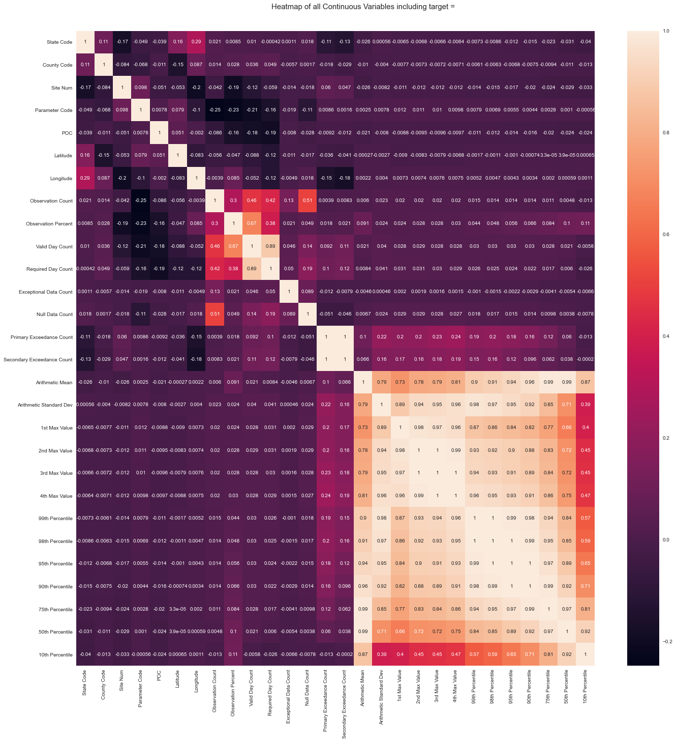

I have also analyzed the above heat map of all the continuous variables including the target variable.

Also, in the below image we can see that the distribution of Defining parameters which are categorized as 15 and Ozone stands as the top most parameter in the contribution of AQI analysis. Carbon monoxide is the least and PM 2.5 is the second most in the plot.

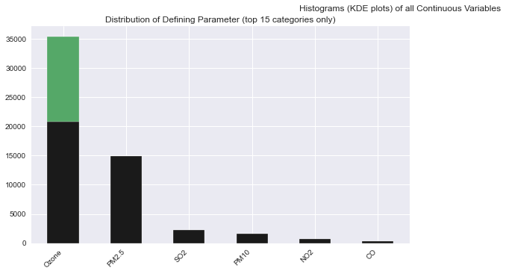

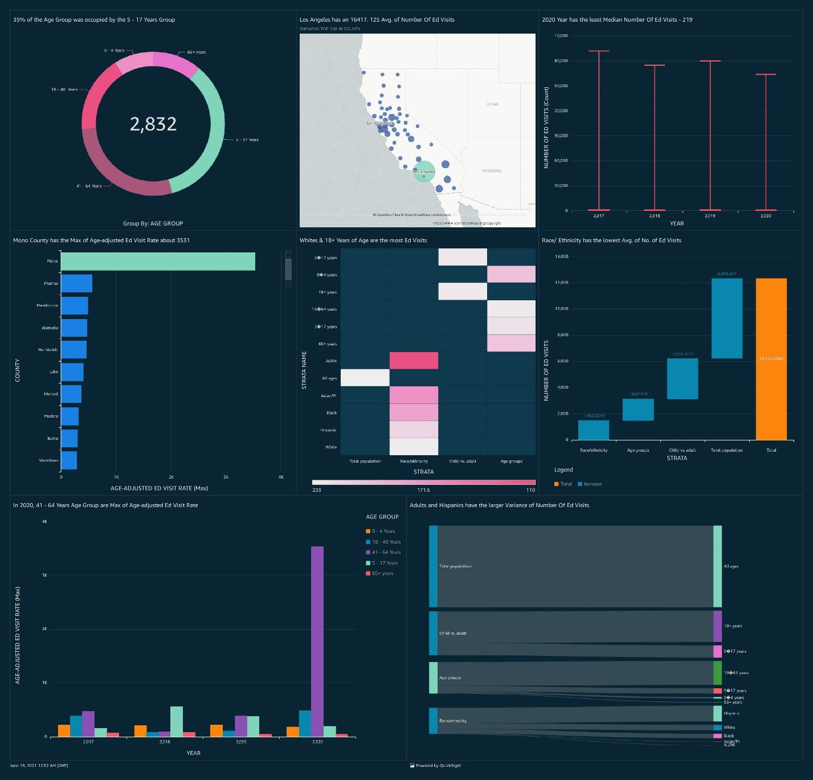

The above showcases the ER Visits of the people in the USA. I observed many insights from this plot and I suggest Keva Health with relevant recommendations and strategies. I see that there is 35% of the Age Group was occupied by the 5 - 17 Years Group. And, Los Angeles has a 16417. 125 Avg. of Number Of Ed Visits in the USA. I see that Mono County has the Max of Age-adjusted Ed Visit Rate about 3531 Whites & 18+ Years of Age are the most Ed Visits in the country. In 2020, 41 - 64 Years Age Group are Max of Age-adjusted Ed Visit Rate among other age groups. Also, the 2020 Year has the least Median Number Of Ed Visits – 219. I found that Race/ Ethnicity has the lowest Avg. of No. of Ed Visits and Adults and Hispanics have the larger Variance of Number Of Ed Visits among others in the country.

This is known as data twiddling, and it is a crucial part of that Process. The data I've been working with won't be ready for investigation right immediately; it'll ought to be altered and sorted first. We'll rank one parameter a lot, so we can order multiple factors by supplying one yield considerable first then the others. I also expedited the teams work progress by knowing them in a scheduled way. I have organized group meetings and enabled greater standards of productivity. I have a major impact on the visualizations and statistical methods that we used in our findings.

**Conclusion:**

So, my advice to Keva Health is to develop and implement a treatment plan for everyone. By conducting proper analysis and study, you can provide support and increase it. Patients can benefit from advanced technological solutions to help them manage their respiratory issues. Create an easy-to-use platform for monitoring, analyzing, and resolving lung health issues. In order to give people with the greatest therapy options, apply data mining algorithms and cognitive computing in the creation of innovative therapeutic targets. It enables clinicians to become more precise, aggressive, and productive. This has the ability to accelerate medical practices and develop fresh skills and resources to researchers, doctors, and caregivers to assist them get in on their care plan. It leads the way that considers the person's medical genetics, behavior, and environment.

**Reference:**

[1] University of Chicago. (July 13, 2020). How Health Care Analytics Improves Patient Care. *Health Informatics Blog.* Retrieved from https://healthinformatics.uic.edu/blog/how-health-care-analytics-improves-patient-care/